



28th June 2026

8am: Said Holy Communion, or Matins (1662 BCP)
10am: Parish Eucharist
Followed by Admission to Communion group in the Parish Centre

Readings: Gen 22.1-14, Psalm 13, Rom 6.12- end, Matthew 20.40 - end

Isaiah 42.1-9 | Acts 10.34-43 | Matthew 3.13 to end

e

The Week at St Margaret’s, Putney

Tuesday
9:30am – 11.30am Little Maggie’s Play Group

2pm – 3.30pm Contemplative Prayer Group

Wednesday
11am Holy Communion followed by coffee, tea and fellowship.

Thursday
12.30pm Lunch on the Lane

Sunday 5th July
St Margaret’s Day
With fellowship and lunch after the 11am service

Readings: Gen 24.34-38,42-49, 58 – end; Psalm 45.10 – end; Rom 7.15-25a; Matt 11.16-19, 25 - end

Genesis 1.1-23 | Romans 8.18-25 | Matthew 6.25 to end

ST MARGARET’S DIARY

Saturday 27th and Sunday 28th – 3pm
Romeo & Juliet

St Margaret’s day – 5th July
Service 11am followed by lunch, and a concert from the Amber Trust
Please do sign up to help on the list at the back of church

Saturday Morning Talk July 11th – 9.30am
Charlie Atkins, former barrister, family court Judge and children’s welfare specialist, come along to hear as he shares his perspective on the family justice system.
Coffee and croissants provided

.

For your prayers:
Daniel and Cara, Pat Robjent, Gordon Jones, Mette Marston, Cynthia, Julia Reece, Reg Norman, Dolly Beresford Jones
In memorial: Magdalena, Humphrey, Jeannette and Francis Bios

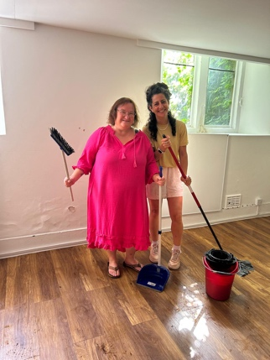

Mor and I have job descriptions which doesn’t include much of the other stuff that we do on a daily basis. On Tuesday our work included redirecting the flow of water from an outdoor tap that couldn’t be switched off, cleverly connecting the garden hose and watering the shrubs, and then sweeping and mopping a great deal of water in the crypt that had come in during the storm we had overnight.
Managing a large old building like St Margaret’s church along with a new parish centre, includes thinking on our feet, resolving issues, contacted day and night for door codes, questions from hirers, broken cupboard locks, and the list goes on. So as I write this Mor is visiting a lady in hospital who fell and broke her hip in church last week, I am working my pastoral skills to their limit on a tricky funeral, and getting the orders of services done for Sunday. It is all part of the service of the church of God.

We are both very grateful to Mark Steward who came to fix the tap, to Jonathan for allowing us to disturb his holiday to answer questions about isolation switches, to Sarah Witney who keeps us organised, clean and tidy.

In the celebration of life services last weekend and the joy of the baptisms the church family came together and did what they do best – joyfully serve, whether it was an active role in the services, cleaning the church, arranging flowers, serving food and refreshments. I have received so many messages this week about the welcome and warmth of St Margaret’s
so, to you all – thank you!
Revd Sarah

Contact details

Curate: The Revd Sarah Curl
curate@stmargaretsputney.org

Parish Administrator: Mor Gartner office@stmargaretsputney.org

Director of Music: Guy Murgatroyd.
music@stmargaretsputney.org

Churchwardens Tony Hawksley & John Roberts
churchwarden@stmargaretsputney.org

Office: 020 8789 5932
www.stmargaretsputney.org

Safeguarding
St Margaret’s operates a policy of good practice with children and vulnerable adults in line with ‘A Safe Church’.
Any concerns please contact our safeguarding officer:

Natasha Hume 07956 814703

No Cash for the Collection?

No problem!
Scan our QR code and get directed immediately to our secure giving page

